Section 4

You have determined that the counting system efficiency for a particular tracer experiment with I-125 is 65%.  You decide that you need a counting rate of 5,200 net cpm in your final sample.  If only 10% of the tracer ends up in the final sample, determine the total dpm of I-125 you must dispense to get the desired 5,200 net cpm in your samples.

A. 5200 cpm/.01 = 52,000 cpm



B. 52,000 cpm/.065 = 80,000 dpm



C. Both A and B



D. None of the above



$\frac{5200}{x}=0.65$, x = 8000, finally 8000/0.1 = 80000

You have designed a tracer experiment using P-32.  Assume the minimum disintegration rate needed per sample is 429 dpm.  Also, you must remember that the best available information indicates that 10% of the labeled material incorporates with the metabolic product.

In order to obtain the minimum desired sample counting results (dpm) for your experiment, the activity (mCi) of the labeled material to be dispensed (per sample) would be?

A. 0.0019



B. 0.429



C. 0.190



D. 0.019

4290dpm

1 microcurie equals 2.22E6 dpm

Ion chamber type instruments are best suited for

A. Identification of radioisotopes



B. Determination of radiation energy



C. Radioactive contamination monitoring (cpm)



D. Radiation field intensity measurements (mR/hr)

You have a swipe sample that was counted for 10 minutes and produced 580 gross counts and the background sample count rate is 19 cpm. Knowing you have a detector efficiency of 30%. What is the level of activity that was detected?

A. 130 dpm



B. 220 dpm



C. 39 dpm



D. None of the above

$$\frac{\frac{580}{10}-19}{0.3}=130$$

Gamma (NaI) and liquid scintillation detection is based upon what physical property?

A. Ionization of a gas



B. Emission of visible/near-visible light



C. Absorption of electromagnetic memory



D. Radiolysis of an organic solvent

Ion Chambers and GM tubes detect radiation based on what physical property?

A. Ionization of a gas



B. Absorption of electromagnetic memory



C. Emission of visible/near-visible light



D. Radiolysis of an organic solvent

You are designing a tracer experiment using 32P.  You are going to isolate a metabolic product of the labeled compound which you will feed to your test animals.  The best available information indicates that **10%** of the labeled material incorporates with the metabolic product.  You need to estimate the amount of isotope, in microcuries, to be dispensed.  You elect to use a liquid scintillation counter (LSC) to obtain your sample results.  You also estimate that you need a minimum count rate of **300 cpm** in the samples to be counted.  **A 0.01 mCi standard of 32P has a gross count rate of 15575 cpm**.  **In 10 minutes, the background yields 250 total counts**.

What is the net count rate for the standard?

A. 15325 cpm



B. 15550 cpm



C. 15600 cpm



D. 15550 dpm

I guess the unit is dpm

Before using portable instruments you should do the following: More than one answer may be correct.

A. Read the operator's manual.



B. Check the batteries and detector operability.



C. Extend the probe cord to its fullest length when monitoring and hold where the cord attaches to the detector.



D. Know the detector's efficiency for the isotope you are using; supplied by Radiation Control.

You have designed a tracer experiment using P-32.  Assume the LSC’s counting efficiency is 70%.

Knowing that your minimum acceptable count rate is 300 cpm per sample, what is the minimum disintegration rate needed per sample?

A. 390 dpm



B. 429 dpm



C. 400 dpm



D. 513 dpm

300/0.7 =429

A standard has a disintegration rate of 93,600 dpm.  Your gamma counter detects 84,554 counts in two minutes.  The gamma counter background sample is 200 cpm.  What is the efficiency of the detector?

A. 45%



B. 65%



C. 80%



D. None of the above

(84554/2 – 200) / 93600 = 0.45

GM type instruments are best suited for

A. Radioactive contamination monitoring (cpm)



B. Radiation field intensity measurements (mR/hr)



C. Determination of radiation energy



D. Identification of radioisotopes

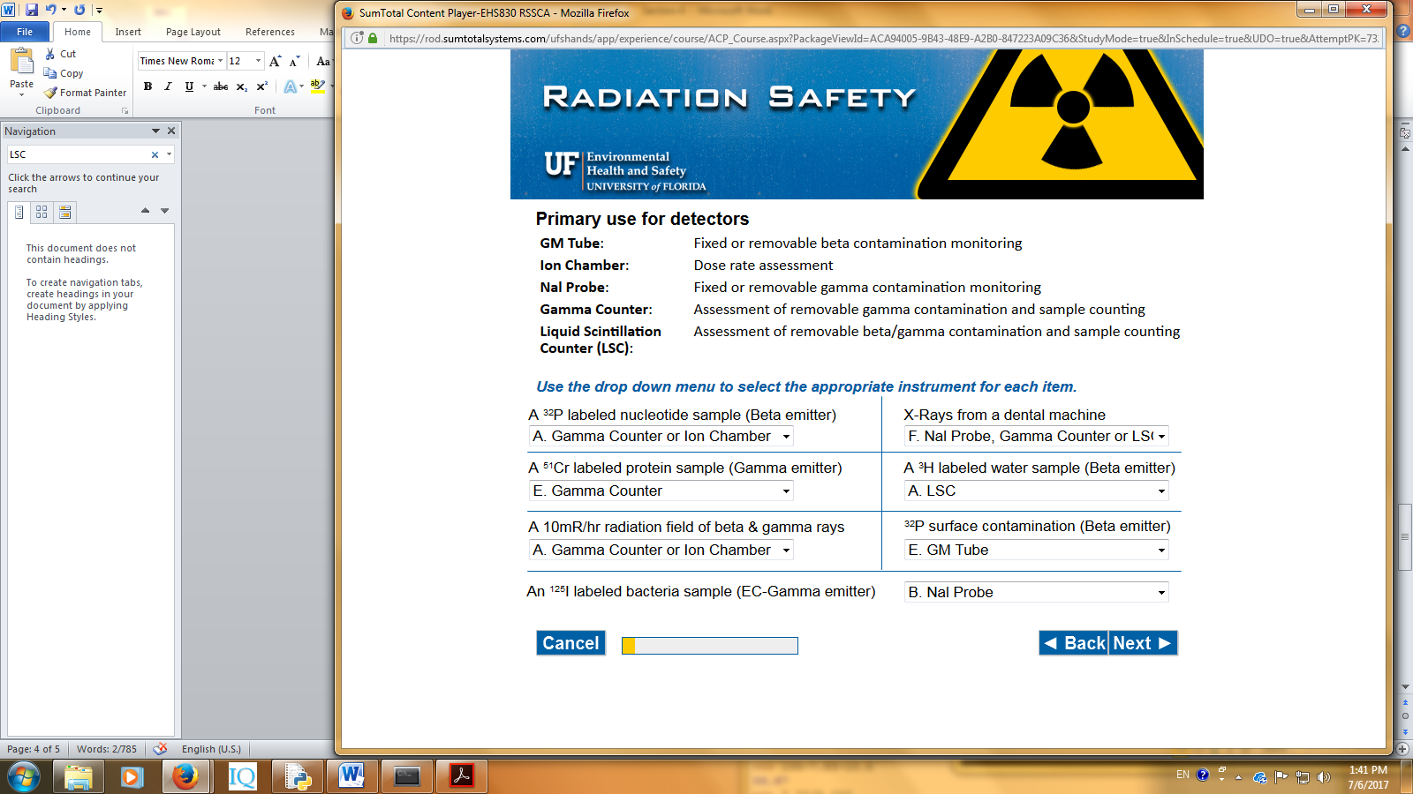

You have a swipe sample that was counted for 10 minutes and produced 580 gross counts and the background sample count rate is 19 cpm.

RCRS recommends that all positive swipe test samples (>100 dpm) be recounted to minimize false-positives.

Knowing you have a detector efficiency of 30%, is this swipe representative of an area that is contaminated according to University of Florida limits?

Yes



No

Not sure for this one

You have designed a tracer experiment using P-32.  Assume that your net count rate for the standard is 15,550 cpm and the standard’s activity is 0.01 uCi at the time of counting, the LSC’s counting efficiency is? (1uCi = 2.22E6 dpm)

A. 1.43%



B. 0.70%



C. 77%



D. 70%

15550/(0.01*2.22E6) = 0.7